
DUY TAN UNIVERSITY
INTERNATIONAL SHOOL

Software Testing
CMU-SE 303 KIS
HOMEWORK
Version 1.0
Date: Nov 8th, 2026

Using Robot FrameWork to Perform Automated Functional Testing on the “ Orange HRM”
Created by <MIS>

Full Name: Linh, Nguyen Thi Thuy
Student ID: 30205149111

Approved by
Sanh, Tran Kim

Elements of Network Security - Mentor:
Name Signature Date
PROJECT INFORMATION
Project acronym | OHRM
Project Title | Orange Human Resource Management
Start Date | 1 Nov 2026 | End Date | 8 Nov 2026
Lead Institution | International School, Duy Tan University
Project Mentor | Sanh, Tran Kim
Scrum master/ Project Leader & contact details | Linh, Nguyen Thi Thuy  Email: Linh, Nguyen Thi Thuy @dtu.edu.vn  Tel: 0342130847  ID: 30219256283
Partner Organization | Duy Tan University
Demo Link | https://github.com/nguyentthuylinh90-dev/Robot-FrameWork.git

REVISION HISTORY
Version | Date | Description
Draft | 1 Nov, 2026 | Initial project report and testing plan.
v1.0 | 8 Nov, 2026 | Completed testing and result analysis.

1. Introduction to OrangeHRM
OrangeHRM is one of the most popular open-source Human Resource Management (HRM) software in the world. This system provides a comprehensive suite of solutions helping small and medium-sized enterprises manage employee information, attendance, leave, recruitment, and performance evaluation.
In the scope of this testing project, the OrangeHRM Demo website (at https://opensource-demo.orangehrmlive.com/) is selected as the System Under Test (SUT). This is an ideal environment for software testing practice as it provides a standard, stable user interface (UI) with clear responses for various interaction scenarios (such as valid/invalid logins, empty fields, etc.), which helps to accurately evaluate the effectiveness of the test cases.
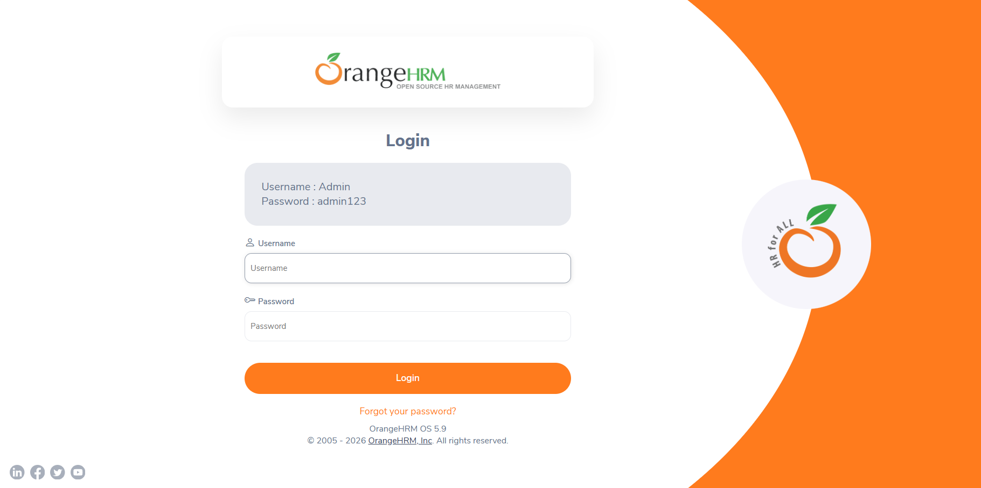
2. Introduction to Robot Framework
Robot Framework is a powerful, open-source test automation framework developed in Python. This tool is designed with a Keyword-driven and Data-driven approach, allowing test engineers to write automation scripts using an easy-to-read tabular syntax that is close to natural language, without requiring highly complex programming skills.
The key features that make Robot Framework the ideal choice for this project include:
- Readability and Reusability: The keyword-driven syntax makes Test Cases transparent and easy to understand, even for those without a coding background.
- Support for Data-Driven Testing: It is perfectly suited for executing a single scenario (e.g., Login) repeatedly with dozens of different data sets (derived from Equivalence Partitioning and Boundary Value Analysis techniques) using the Test Template feature.
- Flexible Integration: It easily integrates with SeleniumLibrary to interact directly with web browser elements (such as entering text, clicking buttons, and verifying error messages).
- Visual Reporting: It automatically generates highly detailed, color-coded (PASS/FAIL) result files (log.html, report.html), which helps testers quickly trace errors (debug) and finalize reports.
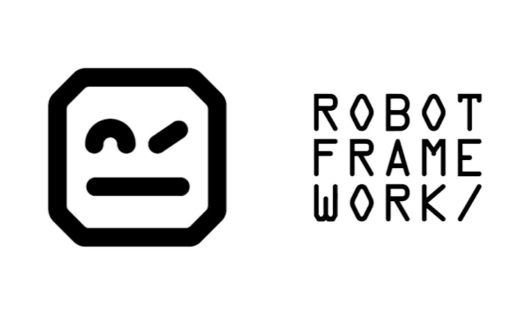

3. Test Case Details

3.1. Test Cases
TC ID | Test Case Name | Data (Username / Password / Expected) | Result
TC01 | Successful login | Admin / admin123 / Dashboard | PASS
TC02 | Incorrect password 1st time | Admin / sai_pass / Invalid credentials | FAIL
TC03 | Incorrect password 2nd time | Admin / abcdef / Invalid credentials | PASS
TC04 | Incorrect username | user_sai / admin123 / Invalid credentials | PASS
TC05 | Uppercase username | ADMIN / admin123 / Invalid credentials | FAIL
TC06 | Empty password | Admin / {EMPTY} / Required | PASS
TC07 | Empty username | {EMPTY} / admin123 / Required | PASS
TC08 | Both empty | {EMPTY} / {EMPTY} / Required | PASS
TC09 | Username with special chars | Admin@123 / admin123 / Invalid credentials | PASS
TC10 | Password with space | Admin / admin 123 / Invalid credentials | PASS
TC11 | Username containing numbers | Admin123 / admin123 / Invalid credentials | PASS
TC12 | Username too long | Admin_Admin_Admin / admin123 / Invalid credentials | FAIL
TC13 | Password contains only numbers | Admin / 123456789 / Invalid credentials | PASS
TC14 | Username with whitespace | Ad min / admin123 / Invalid credentials | PASS
TC15 | All uppercase password | Admin / ADMIN123 / Invalid credentials | PASS
TC16 | Login with email | admin@gmail.com / admin123 / Invalid credentials | PASS
TC17 | SQL Injection username | ' OR '1'='1 / admin123 / Invalid credentials | PASS
TC18 | SQL Injection password | Admin / ' OR '1'='1 / Invalid credentials | PASS
TC19 | HTML code in username | <h1>Admin</h1> / admin123 / Invalid credentials | PASS
TC20 | XSS script in username | <script>alert(1) / admin123 / Invalid credentials | PASS
TC21 | Correct format but wrong data | test_user / test_pass / Invalid credentials | PASS
TC22 | Password is whitespace | Admin / {SPACE} / Required | FAIL
TC23 | Username is whitespace | {SPACE} / admin123 / Required | FAIL
TC24 | Swapped username and password | admin123 / Admin / Invalid credentials | FAIL
TC25 | FAIL: Expected wrong message 1 | Admin / admin123 / Dang nhap that bai | FAIL
TC26 | FAIL: Expected wrong message 2 | Admin / sai_pass / Ban da bi khoa | FAIL
TC27 | FAIL: Expected wrong message 3 | sai_user / sai_pass / Welcome to panel | FAIL
TC28 | FAIL: Expected wrong message 4 | Admin / {EMPTY} / Vui long nhap mat khau | FAIL
TC29 | FAIL: Expected wrong message 5 | {EMPTY} / admin123 / Vui long nhap ten | FAIL
TC30 | FAIL: Expected wrong message 6 | Admin / admin123 / Loi he thong 500 | FAIL

3.2. Equivalence Table
External Condition | Valid Equivalence Class | Number | Invalid Equivalence Class | Number
Username | Correct data ("Admin") | 1 | Empty (Not entered) | 3
 |  |  | Completely incorrect data | 4
 |  |  | Incorrect case ("admin") | 5
 |  |  | Contains extra whitespaces | 6
 |  |  | Special characters, SQLi, XSS | 7
Password | Correct data ("admin123") | 2 | Empty (Not entered) | 8
 |  |  | Completely incorrect data | 9
 |  |  | Incorrect case ("ADMIN123") | 10
 |  |  | Contains extra whitespaces | 11
Account Status | Active (Enabled) | 12 | Disabled / Locked | 13

3.3. Additional Test Cases from New Equivalence Classes
Test Case | Covered Classes | Test Input (Username / Password) | Expected Result
TC08 | 5, 2, 12 | admin / admin123 | Login successful (Username is case-insensitive)
TC09 | 1, 10, 12 | Admin / ADMIN123 | "Invalid credentials" error (Password is case-sensitive)
TC10 | 6, 2, 12 | "Admin" / admin123 | Login successful (if system auto-trims spaces) OR "Invalid credentials" error
TC11 | 1, 11, 12 | Admin / " admin123" | "Invalid credentials" error
TC12 | 1, 2, 13 | Disabled_User / correct_pass | "Account disabled" or "Invalid credentials" error

3.4. Boundary Table
Boundary Condition | Input Username (5-40 chars) | Input Password (7-20 chars) | Expected Result
Minimum - 1 | 4 chars ("Admi") | Valid ("admin123") | Input Error
Minimum | 5 chars ("Admin") | Valid ("admin123") | Valid Login
Minimum + 1 | 6 chars ("Admin1") | Valid ("admin123") | Valid Login
Normal Value | 10 chars ("Admin Test") | Valid ("admin123") | Valid Login
Maximum - 1 | 39 chars | Valid ("admin123") | Valid Login
Maximum | 40 chars | Valid ("admin123") | Valid Login
Maximum + 1 | 41 chars | Valid ("admin123") | Input Error
Empty Input | Empty | Valid ("admin123") | Input Error

3.5. Decision Table
Condition / Action Stub | R1 | R2 | R3 | R4 | R5 | R6 | R7
Valid Username entered | T | F | T | F | F | T | F
Valid Password entered | T | T | F | F | T | F | F
At least one field is empty | F | F | F | F | T | T | T
Actions
Login successful (Dashboard) | ✓ | - | - | - | - | - | -
Display "Invalid credentials" | - | ✓ | ✓ | ✓ | - | - | -
Display "Required" | - | - | - | - | ✓ | ✓ | ✓

4. Evidence
- Source Code: The testing script uses SeleniumLibrary within Robot Framework. Browser initiation ensures setup occurs once, and a Test Template executes the structured data-driven login procedure while clearing cookies prior to each test run.
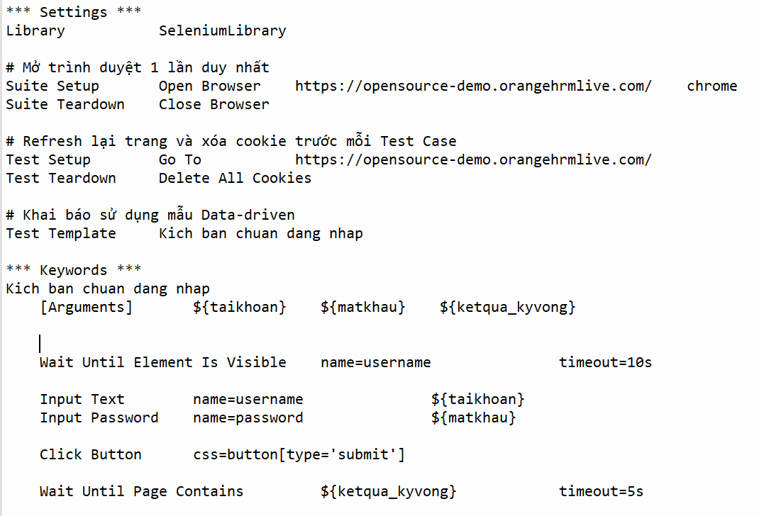

- Terminal Output Execution: The recorded Command Line Interface validates the complete execution of 30 distinct scenarios ranging from basic functionality tests to SQL injections and HTML script inputs.
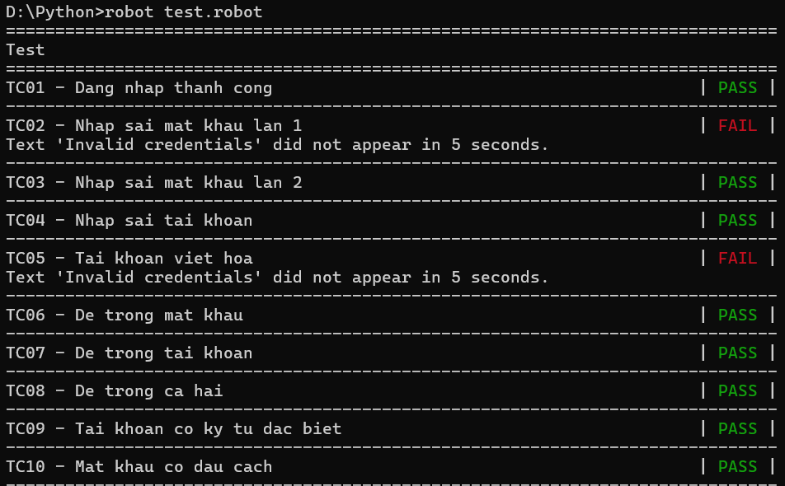
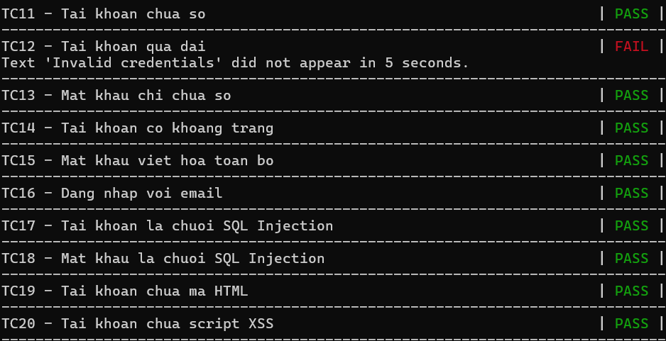
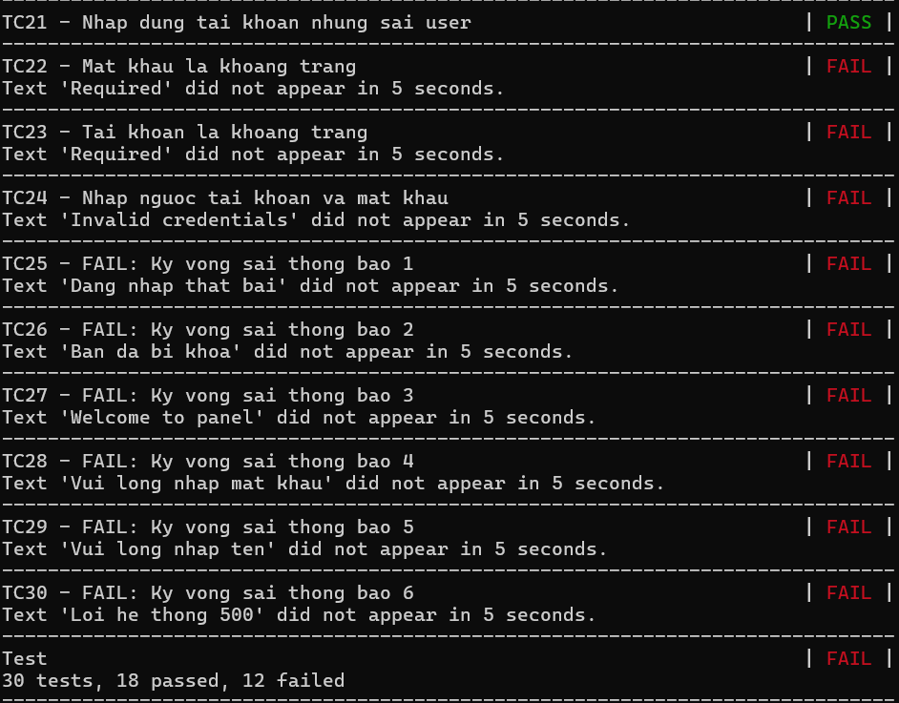
- Result Log Summary: The detailed tracking log verifies the successful run, summarizing the outcome as 18 passed tests and 12 failed tests.


